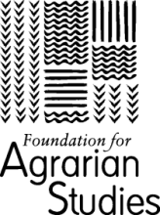

677, First Floor, 9th A Main Road, Indiranagar I Stage, Bangalore 560038, India
<www.agrarianstudies.org>,<office@fas.org.in>

APPLICATION FORM
Third Young Scholar’s Workshop
“Science and Technology in Indian Agriculture”
March 20-23, 2020

Full Name
Current Designation and Organisation/Institute Affiliation
Address
Phone Number
Email ID
Please provide a brief overview of research/work that you have undertaken or seek to undertake in the area of Agrarian studies, village studies, agricultural economics, technological adoption, science and society (Not more than 200 words)

Reason for Applying for this Workshop (Not more than 200 words)

Referee name and details

Please email the completed application form along with a copy of your updated Curriculum Vitae to “sandipan@fas.org.in” by January 25, 2020.

